St. Peregine Lazioso
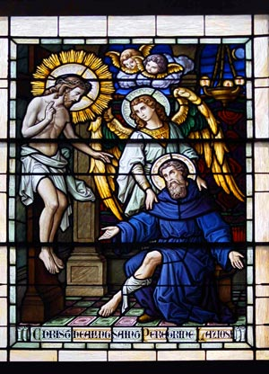In 1283 Saint Philip, Prior General of the Friar Servants of Saint Mary, attempted to lead back to obedience to the Apostolic See the citizens of Forlì then under interdict. He was driven out of the city with insults and violence. While this true follower of Christ was praying for his persecutors, one of the crowd, an eighteen year old by the name of Peregrine of the famous Laziosi family, repented and humbly asked Philip for forgiveness. The holy Father received him with love. From that moment the young man began to scorn the vanities of the world and to pray most fervently to the Blessed Virgin, asking that she show him the way of salvation. A few years later, guided by the Virgin, he received the habit of Our Lady in the priory of Siena where he dedicated himself to her service. There, together with Blessed Francis of Siena, he committed himself totally to the Servite life.

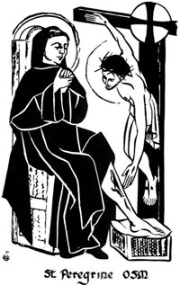After some years he was sent back to Forlì where, because of his love for God and Our Lady, he gave himself to the recitation of psalms, hymns and prayers, and to meditation on the law of God. On fire with love for others, he lavished a wealth of charity on the poor. It is said that he miraculously multiplied grain and wine during a severe shortage in his area.
Above all else, he was outstanding in his love for penance; in tears, he would reflect on the errors which he thought he had made and would frequently confess to the priest. He afflicted his body with various forms of mortification: when tired he would support himself on a choir stall or a rock; when overcome by sleep, he preferred the bare earth to a bed. As a result of this type of life, at the age of sixty he suffered from varicose veins which degenerated into cancer of the right leg.
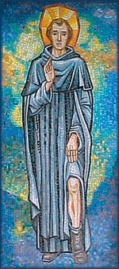His condition deteriorated to the point that a physician, Paolo Salazio, who visited him in the priory, decided, with the consent of all the friars, to amputate the leg as soon as possible. The night before the operation Peregrine dragged himself before the crucifix in the chapter room. There he became drowsy and seemed to see Jesus descend from the cross to heal his leg. The following day, the doctor arrived to perform the amputation but could find no sign of the cancer, or even of a wound. He was so shocked that he spread the news of the miracle throughout the town. This only increased the people’s veneration of Peregrine. The saint died of a fever about 1345 when he was almost eighty years old. An extraordinary number of people from the town and countryside honored him in death. Some of the sick who came were healed through his intercession.
His body rests in the Servite church of Forlì where it is greatly honored by the people. Pope Paul V declared him blessed in 1609 and Pope Benedict XIII canonized him in 1726.
Peregrine was born in Forli, Italy, around 1265. At that time, Forli was governed by the Pope as part of the Papal States, and Peregrine grew up in a family that was actively involved in the opposition, or anti-papal party. Because of anti-papal activity, the city was under the church penalty of interdict, meaning that Mass and the Sacraments could not be celebrated there. St. Philip Benizi, Prior General of the Servants of Mary, went to Forli to preach reconciliation. Young Peregrine, very intense in his political fervor, not only heckled Philip during his preaching, but, in fact, struck him. Philip, instead of responding with anger and violence to the attack, turned and forgave Peregrine.
This encounter with Philip is said to have dramatically changed Peregrine. He began channeling his energy into good works and eventually joined the Servants of Mary in Siena, Italy. He returned to Forli, where he spent the rest of his life, dedicating himself to the sick, the poor, and those on the fringes of society. He also imposed on himself the penance of standing whenever it was not necessary to sit. This led to varicose veins, which later deteriorated into an open sore on his leg, and was eventually diagnosed as cancer.
Peregrine's leg wound became so serious that the local surgeon decided to amputate the leg. The night before the surgery, Peregrine prayed before the image of the crucified Christ, and when he awoke, the wound was healed and his leg saved. He lived another 20 years, dying on May 1, 1345, and the age of about 80. Peregrine was canonized on December 27, 1726, and has been named the Patron Saint of those suffering from cancer.

