**The 2014 Franciscan University of Steubenville Youth Conference**

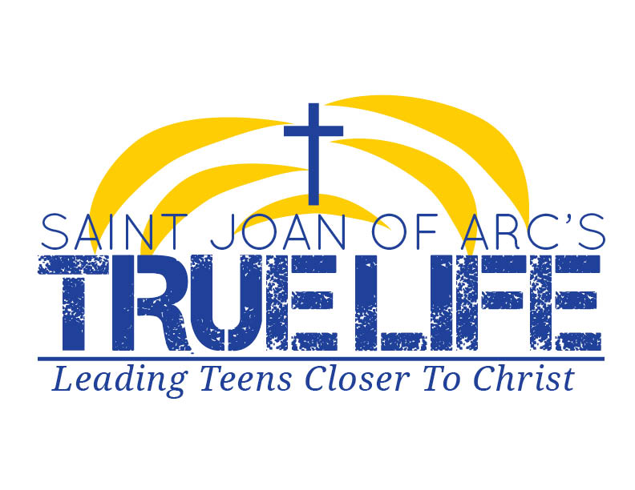



GENERAL INFORMATION

True Life’s High School Youth Ministry will be attending the Franciscan University of Steubenville’s Summer Youth Conference in Steubenville, Ohio from Friday, June 13th, 2014 to Sunday June 15th, 2014. We will be leaving on the bus at 8:00 AM sharp on Friday morning, and will return to Saint Joan of Arc at 6:00 PM on Sunday. Over the course of three days teens will be given an opportunity, for all who are searching, who know God, or wanting more, to experience who God Is. Special for this conference will include the worship leadership of world-renowned Catholic musician Matt Maher, and speakers from across the country ready to join in on this phenomenal weekend of fun, faith, and fellowship. We hope that you will allow your child to participate in this energizing conference. Please complete the permission slip below and ensure that we have it no later than April 25th, 2014. If you have any questions, please contact Justin Yglesias at (305) 562-7107 or jdyouthministry@gmail.com.

COST

At True Life, we try to keep costs to an absolute minimum for all activities while providing a high-quality experience. The cost for the Conference will be $185.00, which will include food, admission, sleeping arrangements at Franciscan University, overall snacks, entertainment, and ministry costs for the night. Please bring any spending money for the various booths available for browsing and for lunch on Friday

REGISTRATION

You can register at <https://liability.steubenville.org/app/5cf141>

**After you submit, your liability form will be appear on your screen. You must **Print** the generated form, have it **signed** by one of your parents/guardians, and **turn it in** to your Group Leader**

Attach the form to the packet as follows, including the $185.00 Retreat Charge, and turn those forms in ASAP!

WHAT TO BRING

-Sleeping Bag and Pillow

-Toiletries, a Washcloth, and Towel

-An Umbrella or other Rain Gear

-A Backpack to carry belongings throughout the day

-A Sweatshirt or jacket

-fan for the room

-sunblock

-Bible, Notebook, Pen

-Spending Money

-Appropriate Clothing

WHAT NOT TO BRING

-Bad Attitude

-Video Games, iPods, Any Electronic Devices

-Drugs, alcohol, cigarettes, matches or other inappropriate items

*If you bring any of these items you will be sent home at your parent’s expense!!*

**ANY STUDENT WHO BECOMES A**

**DISCIPLINE PROBLEM WILL BE SENT HOME**

*Dear Parent/Legal Guardian:*

Your son/daughter is eligible to participate in a St. Joan of Arc Youth Ministry sponsored activity that may require transportation to a location away from our facility. This activity will take place under the guidance and supervision of authorized personnel from the St. Joan’s Office of Youth Ministry. A brief description of the activity:

**Name of Event: Franciscan University of Steubenville Youth Conference**

**Location: Saint Joan of Arc Catholic Church (Transportation to Franciscan University of Steubenville)**

**Date: June 13th-15th, 2014**

**RELEASE & INDENTIFICATION AGREEMENT & MEDICAL POWER OF ATTORNEY. APPLICANTS UNDER THE AGE OF 18 MUST HAVE THEIR PARENT OR GUARDIAN SIGN THIS RELEASE AND EMERGENCY MEDICAL POWER OF ATTORNEY:**

1. As a parent or guardian of the participant, I give my permission for my child to register for and

attend this event and further, in consideration of the acceptance by the St. Joan of Arc Office of Youth Ministry of such registration, I agree individually, and on behalf of my child, to the terms of the above release of liability.

1. I appoint the Pastor or his agents who are acting as leaders of the activity as my attorney-in-fact

to act for me in my name and on behalf, in any way that I could act if I were personally present, with respect to the following matters if any injury, illness or medical emergency occurs during the activity: to give any and all consent and authorization to any physicians, dentists, hospital or other persons or institutions pertaining to any emergency medications, medical or dental treatments, diagnostic or surgical procedures or any other emergency actions as my attorney shall deem necessary or appropriate for the best interest of my child.

1. I, the lawful parent of _____________________________________ (the child), release from all

Liability, and indemnify and hold harmless the Pastor of St. Joan of Arc Church, both individually and as trusted for the Parish and its agents from any and all liability, actions, causes of actions, claims, judgment, cost or expenses, including attorney fees, known or unknown at this time, arising out of or in any way related to any injury or illness incurred by my child while participating in or traveling to or from the activity.

1. The powers and authority granted by me herein may be revoked by me by written notice

delivered to the Pastor or his agents who are then acting or have previously acted hereunder. Without any such written notice, this power of attorney shall not be affected by my disability, incapacity or adjucated incompetency. This power of attorney shall lapse automatically upon completion of the activity and return of my child to the ending place.

CODE OF BEHAVIOR

We expect all participants to conduct themselves with Christian dignity, self-respect, and respect for others. In light of the number of participants, to ensure safety and a positive experience, we feel it necessary to state and enforce these guidelines:

1. Youth in attendance must stay and participate in the entire event.

No one may leave the premises unless accompanied by an adult.

1. The possession or use of alcohol/tobacco/drugs or weapons of any kind is not permitted.
2. Offensive language is not tolerated.
3. Participants must heed any and all directions of the adult staff.
4. Participants must respect the right and property of others. Damage to or defacing of property will be **the financial responsibility of the youth involved and their parents/legal guardians.**
5. Failure to abide by this code of behavior may result in a phone call to parents, who will be required to immediately transport their child off the premises.

Thank you for your support in providing a safe, fun, and faith-filled experience for the young people of St. Joan of Arc.

**I HAVE READ AND UNDERSTAND ALL CONTAINED IN THIS AGREEMENT:**

PARTICIPANT’S SIGNATURE___________________________________________ DATE:_______

PARENT/GUARDIAN SIGNATURE_______________________________________ DATE_______

HOME PHONE___________________________ WORK PHONE____________