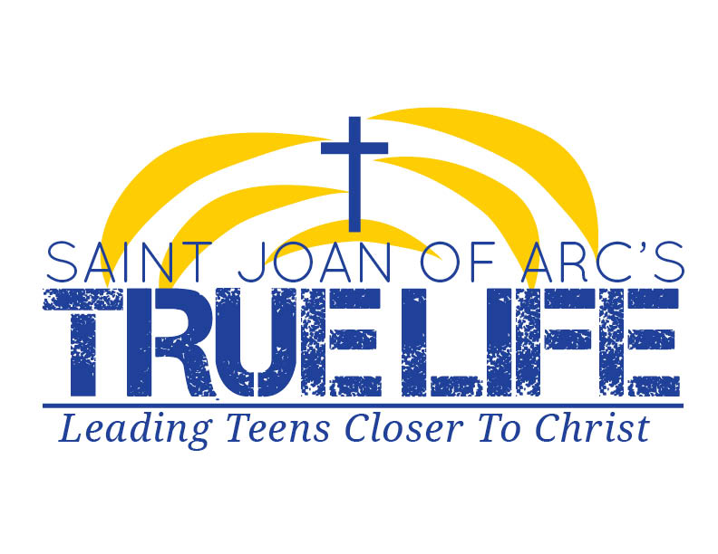

**The 2014 Lenten Lock-In**

GENERAL INFORMATION

True Life’s High School Youth Ministry will have a lock-in at the church on Friday, March 21st, 2014. Teens will arrive at the church at 6:30 PM on Friday, March 21st, and they will head home at 7:00 AM on Saturday, March 22nd. Combining fun activities with an assortment of topics to deepen and empower their faith, this is a Lock-In like no other. Special for this Lock-In will include a trip to the premiere of *God’s Not Dead* the Movie, and an opportunity to take part in our Parish Fish Fry Friday night. We hope that you will allow your child to participate in this fun event. Please complete the permission slip below and ensure that we have it no later than the time you drop your child off for the event. If you have any questions, please contact Justin Yglesias at (305) 562-7107 or jdyouthministry@gmail.com.

COST

At True Life, we try to keep costs to an absolute minimum for all activities while providing a high-quality experience. The cost for the Lock-In will be $30.00, which will include food, tickets for the 2014 Saint Joan of Arc Fish Fry upon their arrival, sleeping arrangements, cost for bus trip and tickets to the premiere of *God’s Not Dead* the Movie, and overall snacks, entertainment, and ministry costs for the night.

**WHAT TO BRING:**

-Good Attitude

-Sleeping Bags, Pillows, Toothbrush/Toothpaste

-Comfortable Clothing

*If desired, change of clothes for the morning*

**WHAT NOT TO BRING:**

-Bad Attitude

-Video Games, iPods, Any Electronic Devices

-Drugs, alcohol, cigarettes, matches or other inappropriate items

*If you bring any of these items you will be sent home at your parent’s expense!!*

**ANY STUDENT WHO BECOMES A**

**DISCIPLINE PROBLEM WILL BE SENT HOME.**

OFFICE OF YOUTH MINISTRY

**ST. JOAN OF ARC CATHOLIC CHURCH**

# POWELL, OHIO

## Parent Permission, Medical Release and Code of Behavior Agreement

### Name of Participant _________________________ Phone _____________________

Address _______________________ City ________ State __________ Zip _______

D/O/B ___________ Male_____ Female_____ School____________ Grade____

**EMERGENCY CONTACT INFORMATION**

Parent or Guardian: _______________________________________________________

Address: ________________________________________________________________

City: ________________________________ State:______________ Zip: ____________

Medical Conditions: _______________________________________________________

________________________________________________________________________

Medical Insurance: _______________________________ Policy Number: __________

Address: _______________________________________ Phone Number: __________

Member Name: __________________________________ Phone Number: __________

Family Doctor: __________________________________ Phone Number: __________

**Parents’ Consent for Release of Personally Identifiable Information**

The undersigned parents of ______________________________, (Minor’s Full Name) hereby consent to the release of photographs and name of the minor to be used by the Office of Youth and Young Adult Ministry for future promotional programs of the Diocese of Columbus. If you have any questions or concerns, please contact Sean Robinson at (614)241-2565.

Dear Parent/Legal Guardian:

CELL PHONE POLICY

True Life Youth Ministry’s Cell Phone Policy is as follows: at the beginning of the retreat, teens will be asked to provide their cell phones to be held in safekeeping for the duration of the event. Any communication needed between the beginning and end of the event can be provided through Staff phones with any concerns.

STAFF CONTACTS

Mike Barone: (614) 285-2741

Justin Yglesias: (305) 562-7107

Carrie Magalski: (614) 589-7440

**I HAVE READ AND UNDERSTAND THAT I COMPLY WITH TRUE LIFE YOUTH MINISTRY’S CELL PHONE POLICY:**

PARTICIPANT’S SIGNATURE___________________________________________ DATE:_______

PARENT/GUARDIAN SIGNATURE_______________________________________ DATE_______

Your son/daughter is eligible to participate in a St. Joan of Arc Youth Ministry sponsored activity that may require transportation to a location away from our facility. This activity will take place under the guidance and supervision of authorized personnel from the St. Joan’s Office of Youth Ministry. A brief description of the activity:

**Name of Event: Lenten Lock-In**

**Location: Saint Joan of Arc Catholic Church (Transportation to Easton Mall Movie Theater)**

**Date: March 21st-22nd 2014**

**RELEASE & INDENTIFICATION AGREEMENT & MEDICAL POWER OF ATTORNEY. APPLICANTS UNDER THE AGE OF 18 MUST HAVE THEIR PARENT OR GUARDIAN SIGN THIS RELEASE AND EMERGENCY MEDICAL POWER OF ATTORNEY:**

1. As a parent or guardian of the participant, I give my permission for my child to register for and

attend this event and further, in consideration of the acceptance by the St. Joan of Arc Office of Youth Ministry of such registration, I agree individually, and on behalf of my child, to the terms of the above release of liability.

1. I appoint the Pastor or his agents who are acting as leaders of the activity as my attorney-in-fact

to act for me in my name and on behalf, in any way that I could act if I were personally present, with respect to the following matters if any injury, illness or medical emergency occurs during the activity: to give any and all consent and authorization to any physicians, dentists, hospital or other persons or institutions pertaining to any emergency medications, medical or dental treatments, diagnostic or surgical procedures or any other emergency actions as my attorney shall deem necessary or appropriate for the best interest of my child.

1. I, the lawful parent of _____________________________________ (the child), release from all

Liability, and indemnify and hold harmless the Pastor of St. Joan of Arc Church, both individually and as trusted for the Parish and its agents from any and all liability, actions, causes of actions, claims, judgment, cost or expenses, including attorney fees, known or unknown at this time, arising out of or in any way related to any injury or illness incurred by my child while participating in or traveling to or from the activity.

1. The powers and authority granted by me herein may be revoked by me by written notice

delivered to the Pastor or his agents who are then acting or have previously acted hereunder. Without any such written notice, this power of attorney shall not be affected by my disability, incapacity or adjucated incompetency. This power of attorney shall lapse automatically upon completion of the activity and return of my child to the ending place.

CODE OF BEHAVIOR

We expect all participants to conduct themselves with Christian dignity, self-respect, and respect for others. In light of the number of participants, to ensure safety and a positive experience, we feel it necessary to state and enforce these guidelines:

1. Youth in attendance must stay and participate in the entire event.

No one may leave the premises unless accompanied by an adult.

1. The possession or use of alcohol/tobacco/drugs or weapons of any kind is not permitted.
2. Offensive language is not tolerated.
3. Participants must heed any and all directions of the adult staff.
4. Participants must respect the right and property of others. Damage to or defacing of property will be **the financial responsibility of the youth involved and their parents/legal guardians.**
5. Failure to abide by this code of behavior may result in a phone call to parents, who will be required to immediately transport their child off the premises.

Thank you for your support in providing a safe, fun, and faith-filled experience for the young people of St. Joan of Arc.

**I HAVE READ AND UNDERSTAND ALL CONTAINED IN THIS AGREEMENT:**

PARTICIPANT’S SIGNATURE___________________________________________ DATE:_______

PARENT/GUARDIAN SIGNATURE_______________________________________ DATE_______

HOME PHONE___________________________ WORK PHONE____________